Day Trip to Awash National Park

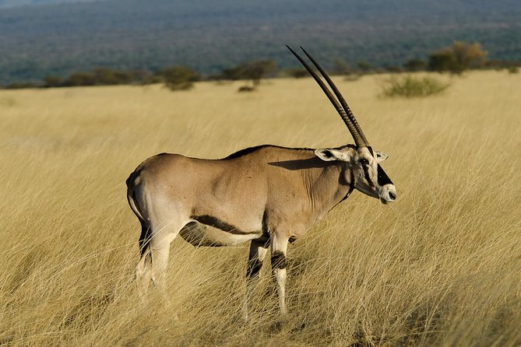
Duration-Full days
Mode of transportation: - Car

Awash National park
Meet you at the airport or hotel then drive to east of Addis Ababa Awash National Park 225 kilometers east of Addis Ababa with its southern boundary along the Awash River and the park covers 756 square kilometers of acacia woodland and grassland. In the south of the park the Awash River gorge has amazing waterfalls. In the upper Kudu Valley at Filwoha is hot springs amid groves of palm trees. In the evening you will have a chance to do a short game drive to see the local wildlife, such as oryx, baboons, greater and lesser kudu, warthogs, gazelles, Columbus monkeys.

